Project Design Phase-II
Data Flow Diagram & User Stories

Date | 6 July 2026
Team ID
Project Name | Online Complaint Registration
Maximum Marks | 4 Marks

Data Flow Diagrams:
A Data Flow Diagram (DFD) is a traditional visual representation of the information flows within a system. A neat and clear DFD can depict the right amount of the system requirement graphically. It shows how data enters and leaves the system, what changes the information, and where data is stored.
DFD Online Complaint Registration level-1

Example: (Simplified)
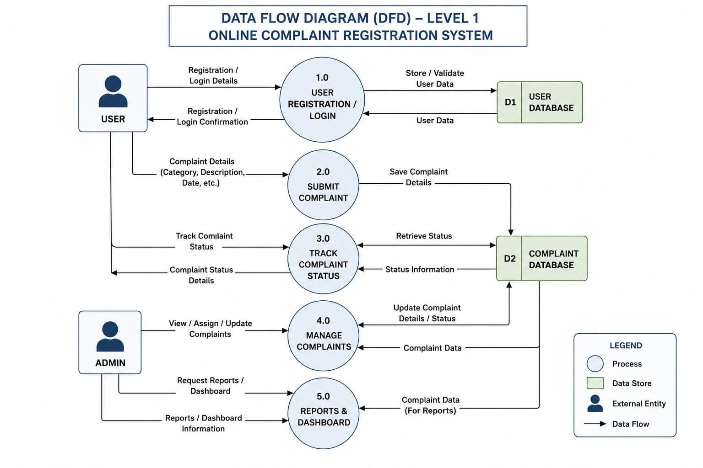


User Stories
Use the below template to list all the user stories for the product.
User Type | Functional Requirement | User Story Number | User Story / Task | Acceptance Criteria | Priority | Release
Customer | Registration | USN-1 | As a customer, I can register using my name, email, phone number and password. | User account is created successfully. | High | Sprint-1
Customer | Login | USN-2 | As a customer, I can log in securely using email and password. | User reaches dashboard after login. | High | Sprint-1
Customer | Submit Complaint | USN-3 | As a customer, I can submit a Complaint by providing category and description. | Complaint is registered successfully. | High | Sprint-1
Customer | Track complaint | USN-4 | As a customer, I can view the status of my Complaint. | Correct complaint status is displayed. | Medium | Sprint-2
Customer | View Complaint History | USN-5 | As a customer, I can view all my previously submitted complaints. | Complaint history is displayed correctly. | Medium | Sprint-2
Customer | Receiver Notifications | USN-6 | As a customer, I receive notifications when complaint status changes. | Notification is delivered successfully. | High | Sprint-3
Admin | View Complaints | USN-7 | As an admin, I can view all submitted complaints. | Complaint records are displayed correctly. | High | Sprint-3
Admin | Update Complaint Status | USN-8 | As an admin, I can update complaint status as Pending, In Progress, or Resolved. | Status updates are saved successfully. | High | Sprint-4
Admin | Manage Users &Reports | USN-9 | As an admin, I can manage users and generate complaint reports. | Dashboard and reports display accurate information. | Medium | Sprint-4

